Presentation format: [_] Oral [_] Poster

The Glarus thrust as a stretching fault
Inga Leman¹, Eda Elgar² and Leo Eula³

¹ Copenhagen University, Inga@xxx.xx
² Birmingham University
³ Basel University

This is the main text … [ca. 300 words or less]

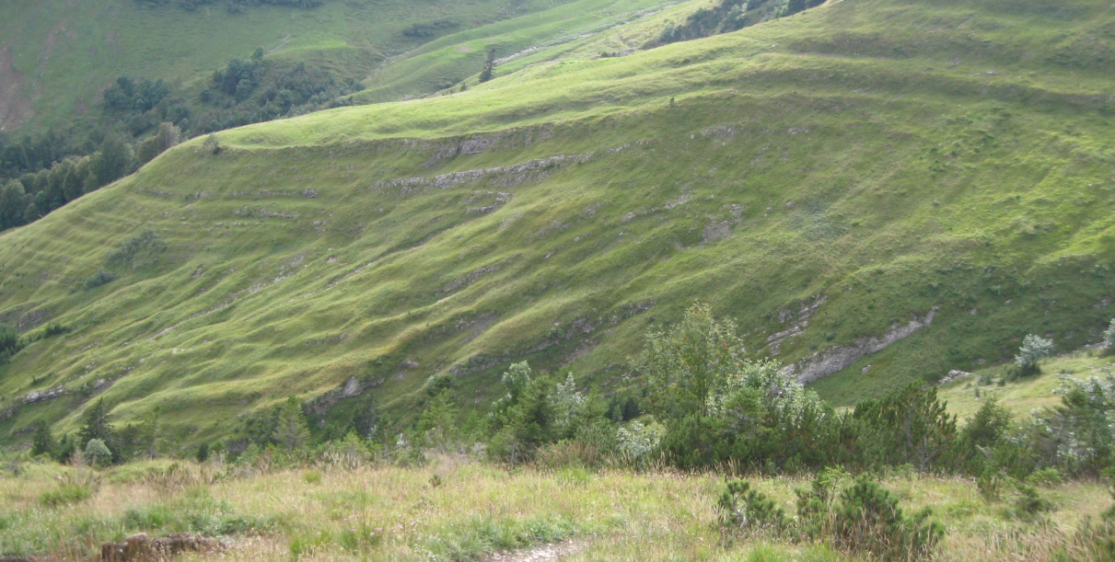

Fig. 1: This is the figure

References
This is the paper

[Altogether one page!]

